

|  |
| --- |
| Sage 50-U.S. Edition  2015.1 Intelligence Reporting  Release Notes  04.2014 |

The software described in this document is protected by copyright, and may not be copied on any medium except as specifically authorized in the license or non‐disclosure agreement.

This document is also protected by copyright, and may not be reproduced or transmitted, in whole or in part, by any means, including photocopying, facsimile transmission, or reduction to any electronic medium or machine‐readable form, without the express written consent of Sage Software Inc.

© 2013 Sage Software, Inc. All rights reserved.

The Sage Software logo and the Sage Software product and service names mentioned herein are registered trademarks or trademarks of Sage Software, Inc. or its affiliated entities. Adobe and Adobe are registered trademarks of Adobe Systems, Incorporate.

Microsoft, the Microsoft logo, Microsoft, MS, MSDOS, FRx, Microsoft® Excel®, Windows and Windows NT are trademarks of Microsoft Corporation. Other product names are trademarks or registered trademarks of their respective owners.

Table of Contents

1.0 Release Notes 3

1.1 Introduction 4

2.0 New Features 5

3.0 Improvements 12

4.0 Resolved Issues 17

5.0 Known Issues 19

# Release Notes

## Introduction

These release notes contain important information about usability and performance enhancements as well as resolved issues in Sage 50-U.S. Edition 2015.1 Intelligence Reporting. The notes within this document highlight the changes made between the release of Sage 50 2015 Intelligence Reporting and Sage 50 2015.1 Intelligence Reporting.

# New Features

## In-memory Report Designer

The new Report Designer boasts a fresh new User Interface to supplement a powerful generation engine utilizing the Report Designer Add-In In-Memory technology allowing for improved performance and usability.

Users have two methods of creating financial reports using the Report Designer:

* For intermediate Excel users the **Task Pane** is a 100% excel experience and offers maximum control and flexibility over report layouts
* For novice Excel users the **Layout Generator** is easy to use and automates the design of reports layouts quickly and accurately.

Task Pane

The new Report Designer has incorporated the Report Designer Add-In Task Pane as an option for intermediate Excel users. Users are able to use the Task Pane to access Chart of Account information and return balances from their General Ledger.

**Location:** Report Manager > Report Designer > Run

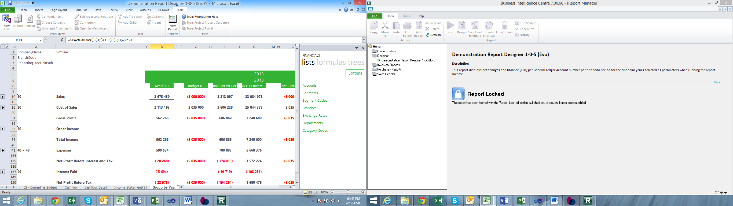

## Layout Generator

The Layout Generator has undergone changes to the user interface to improve usability. Enhancements have been made to the generation engine allowing the Layout Generator to run from the In-Memory Database resulting in improved performance. The Layout Generator creates layouts using formulas that are accessible from the Task Pane empowering users to easily and dynamically update and modify their layouts once generated into Excel.

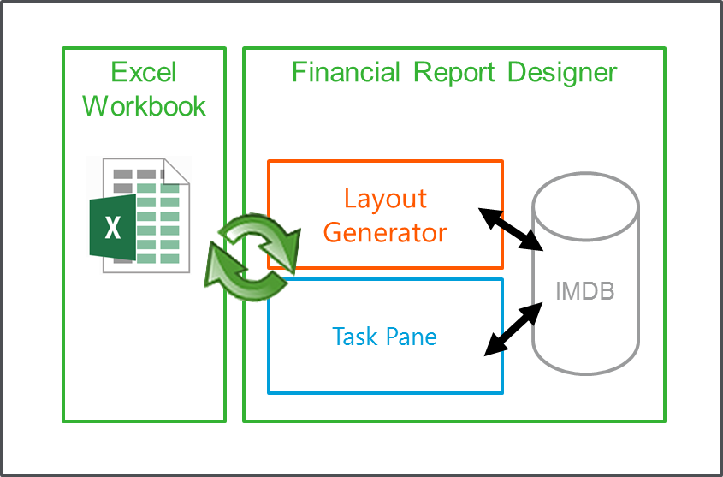

Users will be able to create and edit their layouts in the Layout Design tab. In order to create a layout, users will need to configure the following areas:

**Layout Options** allows users to specify filters which will apply to the entire layout once generated into Excel. Reporting Tree Unit is now included as a layout option.

**Location:** Report Manager > Report Designer > Run > BI Tools > Quick Edit > Balance Sheet > Layout Options

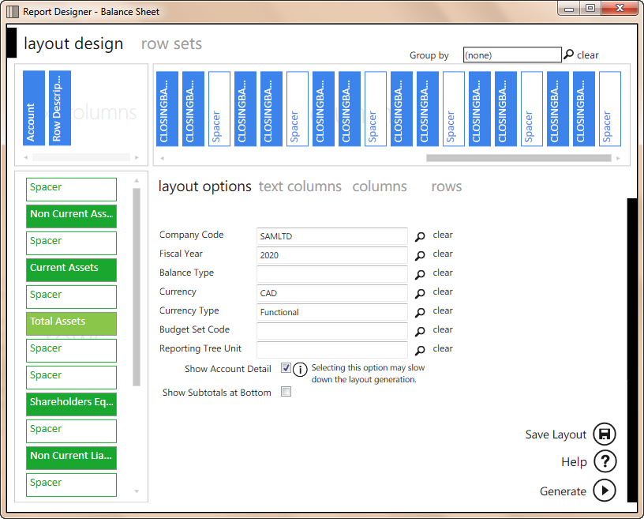

**Text Columns** tab provides users with a predefined set of descriptive columns to add to the layout design.  
  
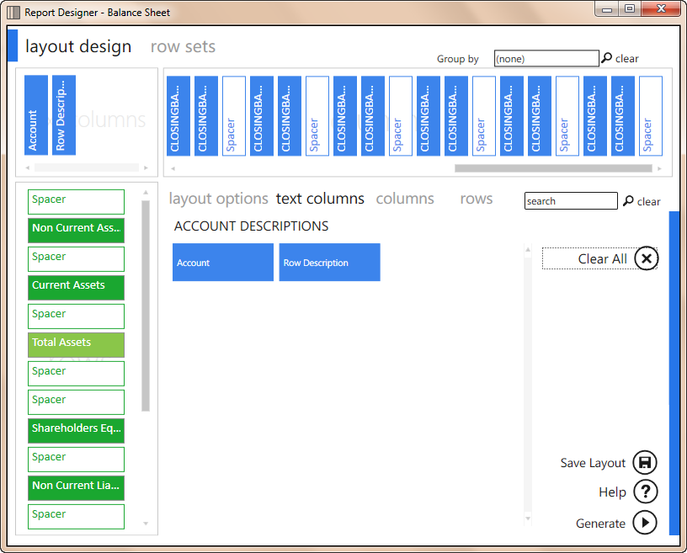

**Columns** provides users with pre-defined columns based on formulas to add to the layout design, in order to return balances from the General Ledger.  
  
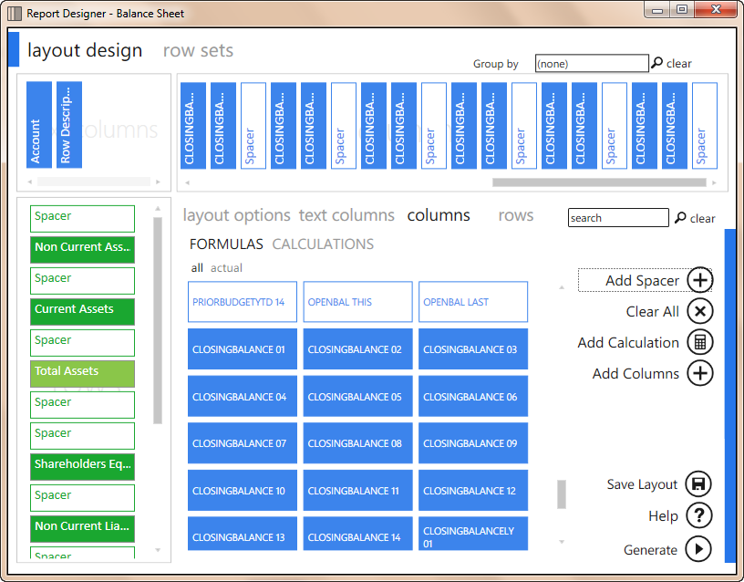

Rows provide users to select their customized rows from the selected row set.  
  
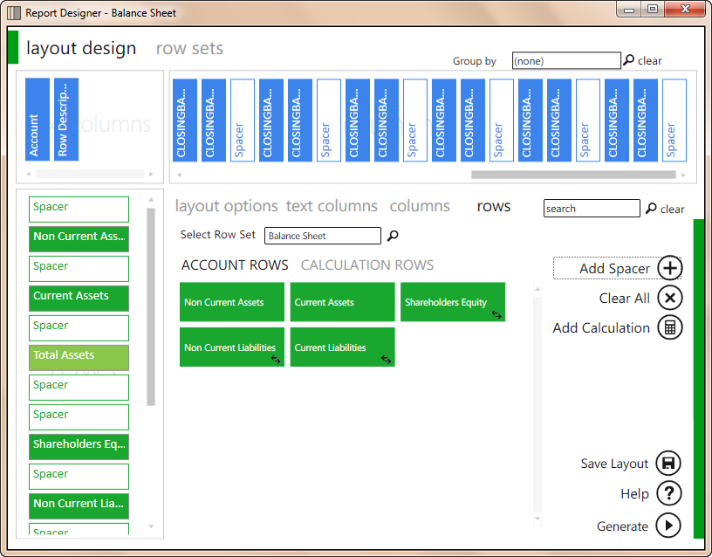

Users can create calculated items using the Calculator which has replaced the Formula Builder.   
  
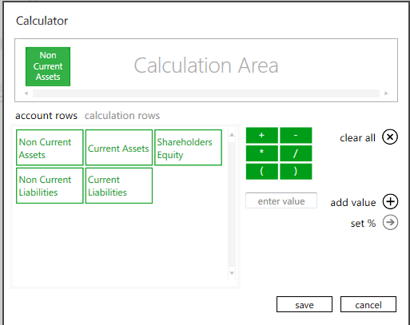

Commonly used layout design functions have been grouped together to improve usability by simplifying usage patterns. The common functions also include the ability to save the Layout Design.

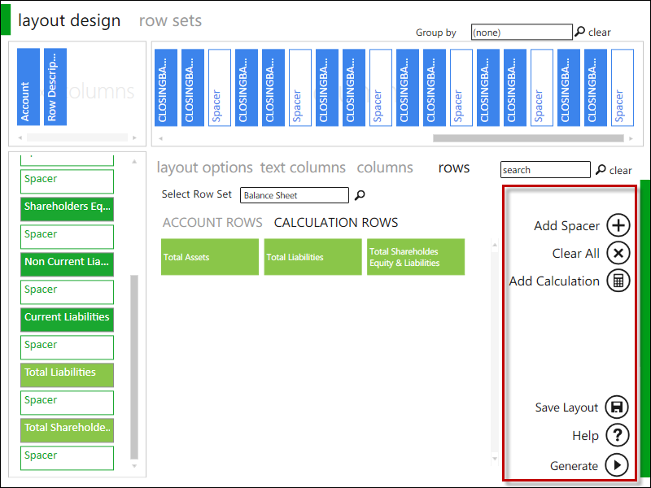

## Row Sets

Rows sets allow the ability to create rules based on Account (GL account number) or GL Category Code.

Row Sets allow users to define customized rows based on rules. The row set is reusable across all layouts in the report and is centrally managed, reducing the time spent customizing and editing rows in reports. A rule preview is available to ensure that the rules return the correct accounts. Once a row set has been defined, users can select to use the row set within their layout design.

Users are able to perform the following actions when managing a row set:

* Add – Adds a new row set
* Edit – Edits the selected row set
* Rename – Allows users to rename the selected row set
* Copy – Allows users to make a copy of the selected row set
* Delete – Deletes the selected row set

**Location:** Report Manager > Report Designer > Run > BI Tools > Quick Edit > Balance Sheet > Row Sets

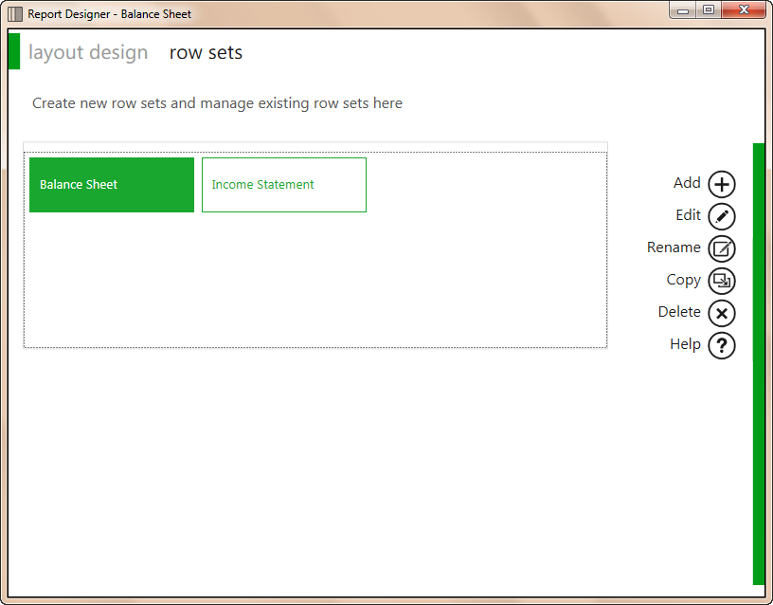

Users are able to perform the following functions within the row set editor:

* Insert – Inserts a new row below the active row
* Clear – Clears the currently selected row
* Save – Saves the row set
* Help – Opens the Sage Intelligence Help File

**Location:** Report Manager > Report Designer > Run > BI Tools > Quick Edit > Balance Sheet > Row Sets

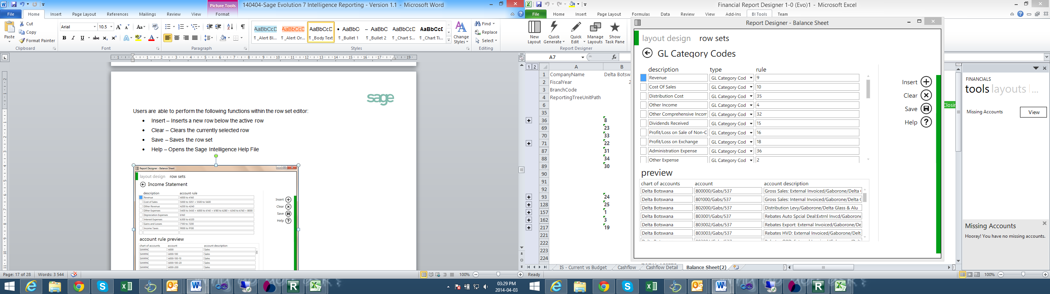

## Look and Feel of the Generated Layout

The look and feel of the layouts generated by the Layout Generator tool has been updated to a more modern and simplistic style.

**Location:** Report Manager > Report Designer > Run > task pane > “Selected layout”

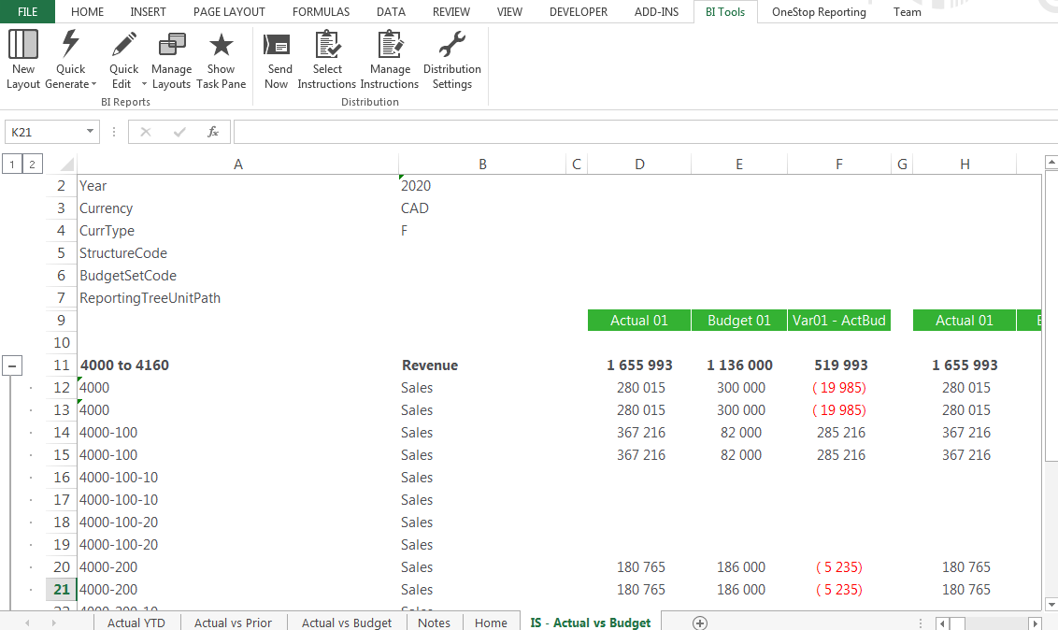

## Missing Accounts

Sage Intelligence Reporting has introduced a new feature which allows you to view the accounts that are missing from your entire report or from the current layout compared to the accounts that exist in the general ledger which has been retrieved by the In-Memory database.

**Location:** Report Manager > Report Designer > Run > task pane > tools

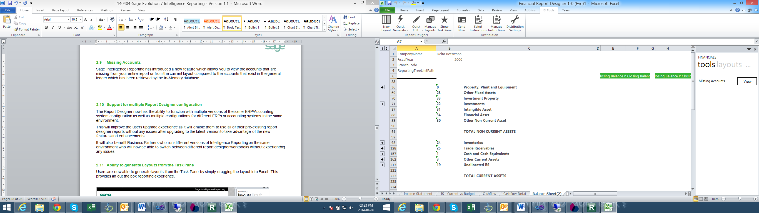

Clicking the dropdown will show the available options to view missing accounts.

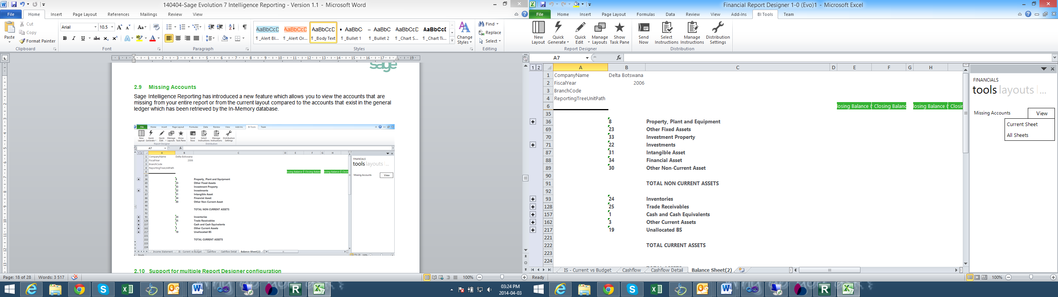

Once a selection has been made, a message will appear keeping the user informed as to whether missing accounts where found, or if there are no accounts missing.

## Support for multiple Report Designer configuration

The Report Designer now has the ability to function with multiple versions of the same ERP/Accounting system configuration as well as multiple configurations for different ERPs or accounting systems in the same environment.

This will improve the users upgrade experience as it will enable them to use all of their pre-existing report designer reports without any issues after upgrading to the latest version to take advantage of the new features and enhancements.

It will also benefit Business Partners who run different versions of Intelligence Reporting on the same environment who will now be able to switch between different report designer workbooks without experiencing any issues.

## Ability to generate Layouts from the Task Pane

Users are now able to generate layouts from the Task Pane by simply dragging the layout into a blank sheet in Excel. This provides an out the box reporting experience.

**Location:** Report Manager > Report Designer > Run > task pane > “Selected Report”

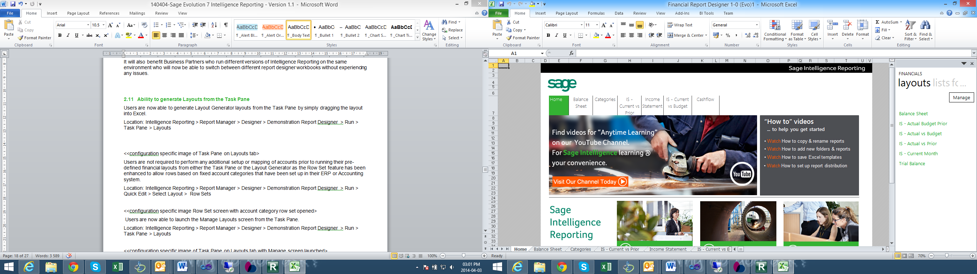

Users are not required to perform any additional setup or mapping of accounts prior to running their pre-defined financial layouts from either the Task Pane or the Layout Generator as the Row Set feature has been enhanced to allow rows based on fixed account categories that have been set up in their ERP or Accounting system.

**Location:** Report Manager > Report Designer > Run > BI tools > Quick Edit > Rowsets

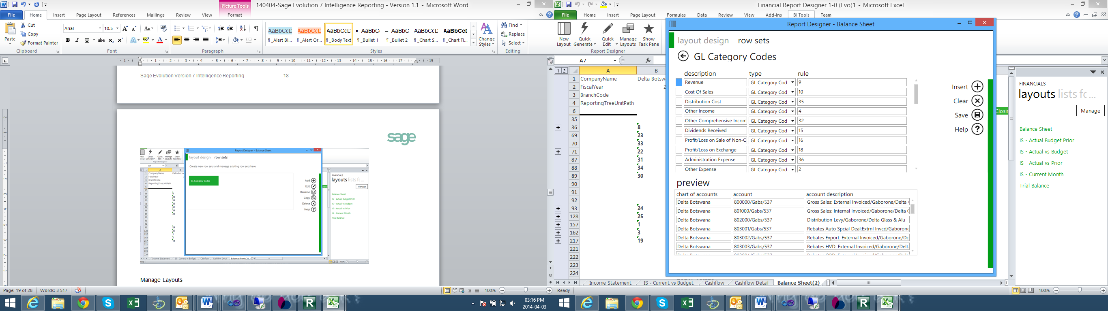

## Manage Layouts

Users are now able to launch the Manage Layouts screen from the Task Pane. This allows users the opportunity to customise layouts to their specifications directly from the task pane.

**Location:** Report Manager > Report Designer > Run > task pane > Layouts > Manage

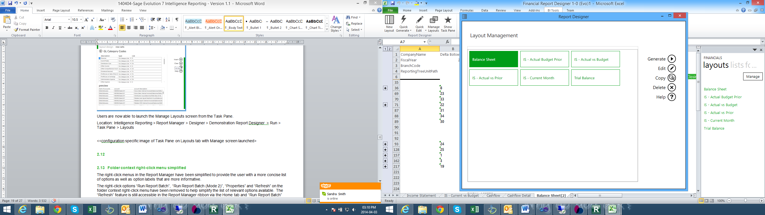

# Improvements

## Excel 64 bit compliance

As of Sage 50 Intelligence Reporting 2015.1 , reports will now be Excel 64 bit compliant

## New look a feel of reports

The Intelligence Reporting demonstration reports have an updated look and feel.

RKL Analysis Dashboard 2-7

**Location:** Report Manager > Demonstration > RKL Analysis Dashboard 2-7 > Run

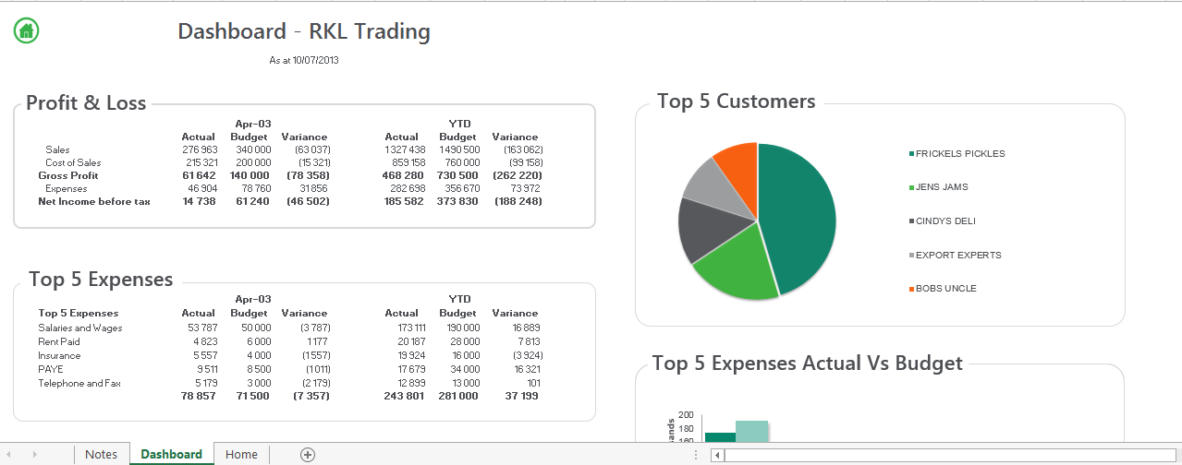

*RKL Dashboard 2-5*

RKL Dashboard 2-5

**Location:** Report Manager > Demonstration > RKL Dashboard 2-5 > Run

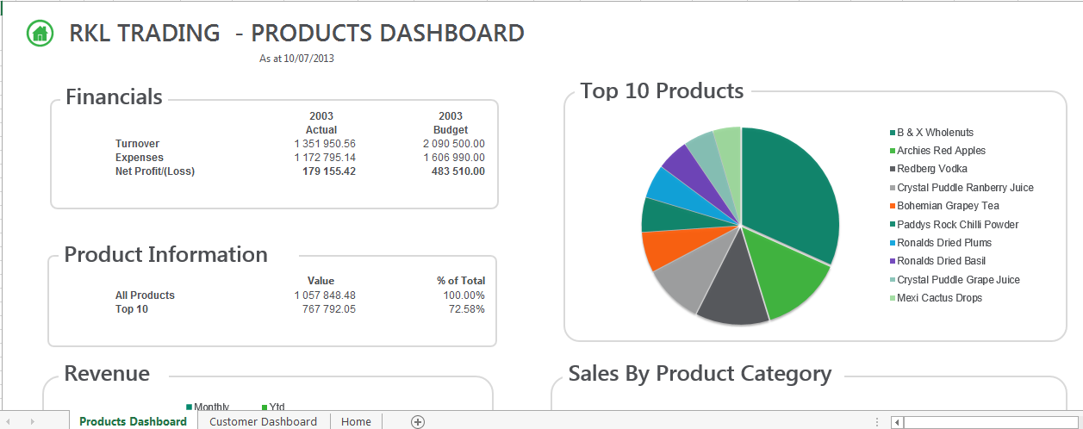

Sales Cube Report 2-0

**Location:** Report Manager > Demonstration > Sales Cube 2-0 > Run

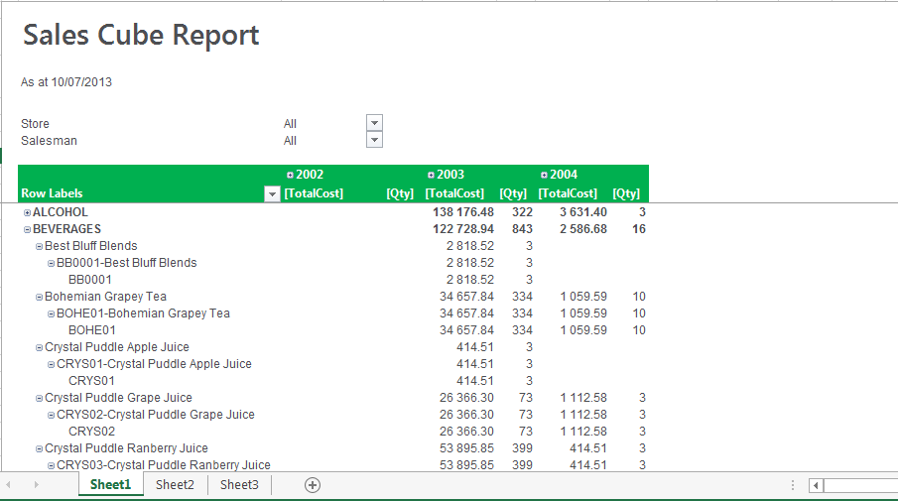

Sales Details 2-3

**Location:** Report Manager > Demonstration > Sales Details 2-3 > Run

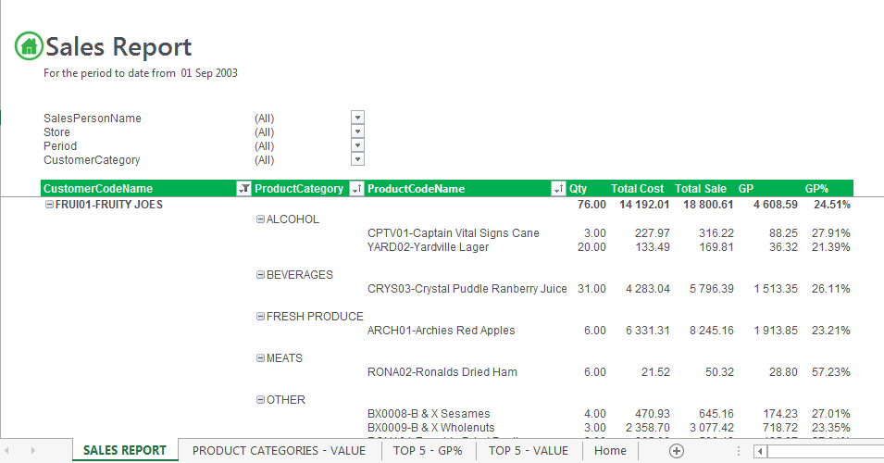

## 3.2 Modernized Run Report Background

Sales Re-order Levels 2-3

**Location:** Report Manager > Demonstration > Sales Re-order Levels 2-33 > Run

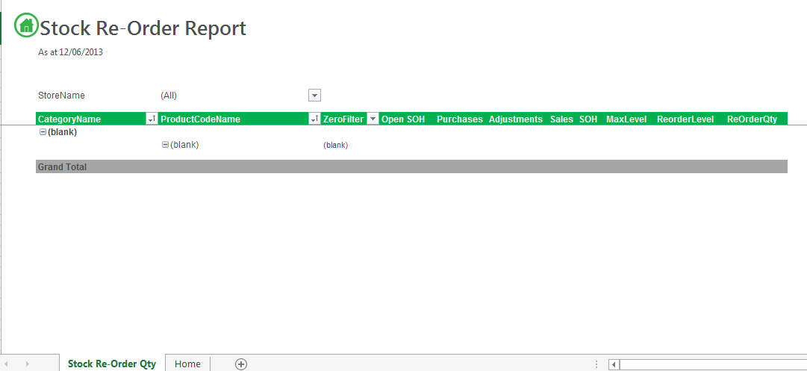

# 4.0 Known Issues

Drill down to transaction ( to be confirmed with Latoria)